Lesson 3 e&c simple curcuits | 

AIM OF THE LESSON

During this lesson students will:
- Explain the importance of electricity in everyday life.
- Explore the concept of a circuit using a battery, copper wire and a globe.
- Describe that batteries have stored energy that is changed into electricity in circuits.


EQUIPMENT

Per Class
- roll of copper wire
- masking tape

Per Group
- 2 D batteries (1.5 volts)
- 2 lengths (15cms) of insulated copper wire with about 1cm of insulation removed at each end
- 1 small globe (have some spares)
- 2 pop sticks for supporting batteries
- blu-tac

Preparation
- Cut the copper wire into 15 cm lengths and remove approximately one cm of insulation at each end (later activities require four lengths per group).
- Globe holders and battery holders are useful for these activities if available.

Safety
- Mains electricity must not be used.


Background Information for teachers

- In order for electricity to travel to where it is needed, there must be a complete circuit or path.
- A complete circuit is like a circle. No circuit will work if it has a break in it.
- A switch can be used to provide a break in a circuit.
- For an electrical appliance such as a light globe to work, it must be joined with conductors (such as copper wires) to make the circuit work.
- A complete circuit must have an energy source (a battery or power source) to make an electrical appliance work.
- An electrical circuit can be made stronger by adding more batteries. This will make the globe shine brighter in a circuit.
- A battery is a device that produces electricity from a chemical reaction.
- A battery has a negative and a positive end (electrodes).
- Electrons flow from the negative end of the battery.
- An electric circuit looks something like this:
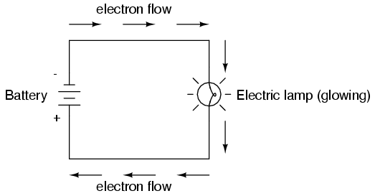

- Correct set up to make the globe light up in the activities needs to include
  - Place the positive end of one battery next to negative end of the second battery.
  - The wires should touch the globe on the metal end with one on the base
and one on the side.
  - A variety of combinations will work.


Lesson Outline

1. Introduction (Engaging Students)
- Brainstorm: Imagine what life would be like without electricity.
- Every student to write one item they would not be able to use. (E.g. toaster, hot water system, hair dryer, radio ) either on a post it note or onto the board.
- Place post it notes on the board.
How could these be classified into groups?
Cooling, heating, sound, cooking, motion, other

- The post it notes could now be classified into these groups.
- In groups of four students complete the handout What Do We Need Electricity For?
- Students list what electricity is needed for at home, at school, in a shopping centre and in a sporting club. Each student in the group to complete one box on the sheet and then share their ideas so the group can complete all boxes.
- Share key ideas with class.
What is meant by an electric circuit?
A path that has no breaks in it that electricity can flow through.

Wire, batteries, globe, switch

Torches, radios, toys, mobile phones, fire alarms and remote controls.

Yes/No.

What materials would you need to make a circuit?

Where have you seen simple circuits?

Have you have had any experience in constructing a simple circuit using batteries, wire and globes.

2. Activities and Strategies

- Write down the aim, equipment and method for the activity.
- Revise what is meant by a prediction. Students view the images of circuits involving a globe, wire and one or more batteries and predict whether the globe will shine.
- In groups students carefully test each prediction and state what changes were necessary to make the circuit work.

3. Focus Questions (Explain and Elaborate)

A complete circuit, wires touching a positive and a negative end of the batteries.

The wires provide a path for electricity to flow along.

Yes, must be positive to negative.

Yes, one to base and one on the side.

Electricity passing through the globe (filament).

In a circuit, the electricity comes from the battery. A battery has ingredients inside it for a chemical reaction, which will react to cause electricity to flow around the circuit.

Any metal as metals are good conductors of electricity.
E.g. alfoil.
If the globe is to light up what do you need to have?

What are the wires for?

Does it matter how you position the batteries?

Does it matter where the wires are placed on the globe?

What makes the globe light up?

Can you explain why a battery is needed?

What could you use if you did not have any copper wire?

4. Reflection
- Write a conclusion that includes the rules for setting up a circuit.
- Read this to a partner.


Extension Activities

- Draw a labelled diagram of all the ways you can get the globe to light up.
- Examine the information on the batteries or globes. Draw a labelled diagram of each.


Links to other learning Areas

- Construct a timeline to show the development of electricity or when a range of electrical items were invented.
- Role-play how people used to cook, clean and light their homes in the 1700s.
- Write a diary entry of ‘a day without electricity’.
- Make a class collage from magazines and advertising brochures that indicates the range of the electrical goods people today use.
- Prepare a poster to show the effects of our use of electricity on our environment.
- Write a list of the different types of batteries, what they are used for and the cost of each.
- Research the history of batteries.
- Make a poster that shows the advantages and disadvantages of the different types of power stations.

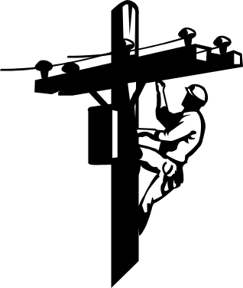

AT HOME
AT SCHOOL

Why Do
We Need Electricity?

IN A SHOPPING
CENTRE
IN A SPORTING
CLUB

ACTIVITY 3 : Simple Circuits | 
Aim (What are we going to find out?)

Equipment (What do I need to complete the task?)

Method (How is the task to be done?)

Results (What did I observe?)

Set up the your materials as shown in each picture | Prediction  Will the globe light up? | Observation  Did the globe light up? | Changes  What did you have to change to make the globe light up?
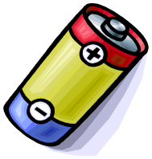



Conclusion (What did I learn about the rules for setting up a circuit?)

